SMC Similarity (Decimal → Bit-Level)
def decimal_to_binary_list(nums, bit_length):
bin_list = []
for num in nums:
b = bin(num)[2:].zfill(bit_length) # Convert to binary and pad with zeros
bin_list.extend([int(bit) for bit in b])
return bin_list

# -------- User Input --------
x = list(map(int, input("Enter decimal numbers for vector X: ").split()))
y = list(map(int, input("Enter decimal numbers for vector Y: ").split()))

# Determine bit length
max_num = max(max(x), max(y))
bit_length = max_num.bit_length()

# Convert to bit-level binary vectors
x_bin = decimal_to_binary_list(x, bit_length)
y_bin = decimal_to_binary_list(y, bit_length)

# -------- Compute SMC --------
q = r = s = t = 0
for a, b in zip(x_bin, y_bin):
if a == 1 and b == 1:
q += 1
elif a == 1 and b == 0:
r += 1
elif a == 0 and b == 1:
s += 1
elif a == 0 and b == 0:
t += 1

smc_similarity = (q + t) / (q + r + s + t)

print(f"\nBit-level vector X: {x_bin}")
print(f"Bit-level vector Y: {y_bin}")
print(f"SMC Similarity (bit-level): {smc_similarity:.4f}")

Jaccard Similarity (Decimal → Bit-Level
def decimal_to_binary_list(nums, bit_length):
bin_list = []
for num in nums:
b = bin(num)[2:].zfill(bit_length) # Convert to binary and pad with zeros
bin_list.extend([int(bit) for bit in b])
return bin_list

# -------- User Input --------
x = list(map(int, input("Enter decimal numbers for vector X: ").split()))
y = list(map(int, input("Enter decimal numbers for vector Y: ").split()))

# Determine bit length
max_num = max(max(x), max(y))
bit_length = max_num.bit_length()

# Convert to bit-level binary vectors
x_bin = decimal_to_binary_list(x, bit_length)
y_bin = decimal_to_binary_list(y, bit_length)

# -------- Compute Jaccard Similarity --------
q = r = s = 0
for a, b in zip(x_bin, y_bin):
if a == 1 and b == 1:
q += 1
elif a == 1 and b == 0:
r += 1
elif a == 0 and b == 1:
s += 1

denom = q + r + s
jaccard_similarity = q / denom if denom != 0 else 0.0

print(f"\nBit-level vector X: {x_bin}")
print(f"Bit-level vector Y: {y_bin}")
print(f"Jaccard Similarity (bit-level): {jaccard_similarity:.4f}")

Cosine Similarity (Decimal Input)
import math

# -------- User Input --------
x = list(map(float, input("Enter elements of vector X: ").split()))
y = list(map(float, input("Enter elements of vector Y: ").split()))

# Check if vectors are the same length
if len(x) != len(y):
print("Error: Vectors must be the same length.")
exit()

# -------- Compute Cosine Similarity --------
dot_product = sum(a * b for a, b in zip(x, y))
norm_x = math.sqrt(sum(a * a for a in x))
norm_y = math.sqrt(sum(b * b for b in y))

# Handle zero-vector cases
if norm_x == 0 or norm_y == 0:
cosine_similarity = 0.0
else:
cosine_similarity = dot_product / (norm_x * norm_y)

print(f"\nVector X: {x}")
print(f"Vector Y: {y}")
print(f"Cosine Similarity: {cosine_similarity:.4f}")

Tanimoto Coefficient (Decimal Input)
# -------- User Input --------
x = list(map(float, input("Enter elements of vector X: ").split()))
y = list(map(float, input("Enter elements of vector Y: ").split()))

# Check if vectors are the same length
if len(x) != len(y):
print("Error: Vectors must be the same length.")
exit()

# -------- Compute Tanimoto Coefficient --------
dot_xy = sum(a * b for a, b in zip(x, y))
dot_xx = sum(a * a for a in x)
dot_yy = sum(b * b for b in y)

denom = dot_xx + dot_yy - dot_xy
if denom == 0:
tanimoto = 0.0
else:
tanimoto = dot_xy / denom

print(f"\nVector X: {x}")
print(f"Vector Y: {y}")
print(f"Tanimoto Coefficient: {tanimoto:.4f}")

Assignment 2: finding gain and best attribute:

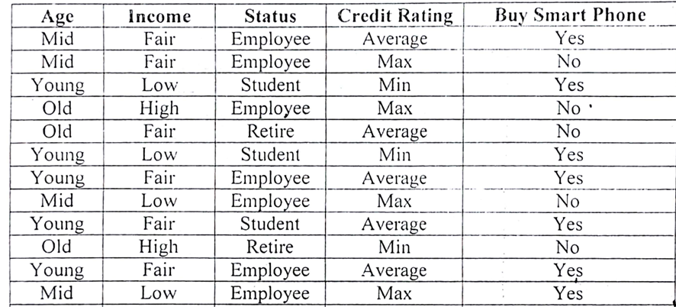

import math

# -------- DATASET --------
data = [
['Mid', 'Fair', 'Employee', 'Average', 'Yes'],
['Mid', 'Fair', 'Employee', 'Max', 'No'],
['Young', 'Low', 'Student', 'Min', 'Yes'],
['Old', 'High', 'Employee', 'Max', 'No'],
['Old', 'Fair', 'Retire', 'Average', 'No'],
['Young', 'Low', 'Student', 'Min', 'Yes'],
['Young', 'Fair', 'Employee', 'Average', 'Yes'],
['Mid', 'Low', 'Employee', 'Max', 'No'],
['Young', 'Fair', 'Student', 'Average', 'Yes'],
['Old', 'High', 'Retire', 'Min', 'No'],
['Young', 'Fair', 'Employee', 'Average', 'Yes'],
['Mid', 'Low', 'Employee', 'Max', 'Yes']
]

features = ['Age', 'Income', 'Status', 'Credit']

# -------- ENTROPY FUNCTION --------
def entropy(dataset):
total = len(dataset)
yes = sum(1 for row in dataset if row[-1] == 'Yes')
no = total - yes

def calc(p):
return -p * math.log2(p) if p != 0 else 0

return calc(yes/total) + calc(no/total)

# -------- INFORMATION GAIN --------
def information_gain(dataset, index):
total_entropy = entropy(dataset)
values = set(row[index] for row in dataset)

weighted_entropy = 0
print(f"\nFeature: {features[index]}")

for v in values:
subset = [row for row in dataset if row[index] == v]
weight = len(subset) / len(dataset)
sub_entropy = entropy(subset)

weighted_entropy += weight * sub_entropy

print(f" Value: {v}")
print(f" Count = {len(subset)}")
print(f" Entropy = {round(sub_entropy, 3)}")

gain = total_entropy - weighted_entropy
print(f" → Information Gain = {round(gain, 3)}")

return gain

# -------- MAIN --------
print("Entropy of dataset:", round(entropy(data), 3))

gains = []
print("\n--- Information Gain Calculation ---")

for i in range(len(features)):
g = information_gain(data, i)
gains.append(g)

# -------- BEST ATTRIBUTE --------
best_index = gains.index(max(gains))
print("\nBest Attribute:", features[best_index])

